Ivavsys Technologies private limited

Screenshot Utility User Guide

© Ivavsys Technologies Pvt. Ltd.

203, Sanskruti Business Center

Bhumkar Chowk, Wakad

Pune 411057, India

Phone. 9881012421

Introduction

This is a Java based utility for capturing Screenshots and automatically creating a proof of testing document.

How does it help

|  |  |  |
| --- | --- | --- |
| **Problem Statement** | **Solution** | **Benefits** |
| * As a best practice manual testers have to document the steps performed during test execution as proof of testing * Normally a tester would need have to perform multiple steps in order to capture the proof like   Select Screen > Print Screen >  Open Word File >  Paste Screenshot >  Enter Test Case Data > Save | A utility which at the click of a button takes a screenshot of the active Window and save to a Word file along with relevant Test Case Information | This utility helps you gain efficiencies in the performance of your daily tasks, minimizing manual effort and increasing productivity |

Pre - requisites

1. Java JDK 1.8 or above
2. Microsoft Office Suite 2007 or above

Getting Started

1. Download and rename ***iScreenCaptureReports-master.zip*** to ***iScreenCaptureReports.zip***
2. Unzip the contents of ***iScreenCaptureReports.zip*** file onto your *Desktop*
3. Go to “Desktop\iScreenCaptureReports\TestData” folder and add test case data to the TestData.xlsx file as per the sample data present in the sheet
4. Navigate to “Desktop\iScreenCaptureReports“ and double-click on **“iScreenCaptureApp.exe”** file

* You can move **iScreenCaptureApp.exe** to any path of your choosing, kindly do not change the file path of the other folders

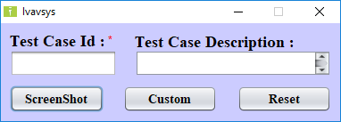

1. Click on the Test Case ID field and enter a valid ID. Press Tab or click on the Description field, it should auto populate as per the data in the **'TestData.xlsx'** sheet.

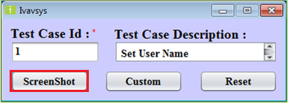

1. Click on “***Screenshot*”** button or hit “***Enter***” to take a screenshot of the active window

* A word file will be automatically created at “Desktop\iScreenCaptureReports\StandardScreenshot” with the format TCID_<test case id>_<date>_<hh>_<mm>_<ss>.docx
* The utility will now automatically read the next Step from the 'TestData.xlsx' sheet and update the Test Case ID and the Description fields
* The screenshot for all the Steps of a Test Case will be saved to the same file
* The utility will automatically 'Reset' once all the Steps are complete and you see the confirmation message that “Screenshot saved successfully”

1. The utility will save the Test Case ID and the corresponding Step Description along with the screenshot to a doc file. Sample below.

**Test Case ID:** 1 **Test Case Step Name:** Set User Name on login Page.

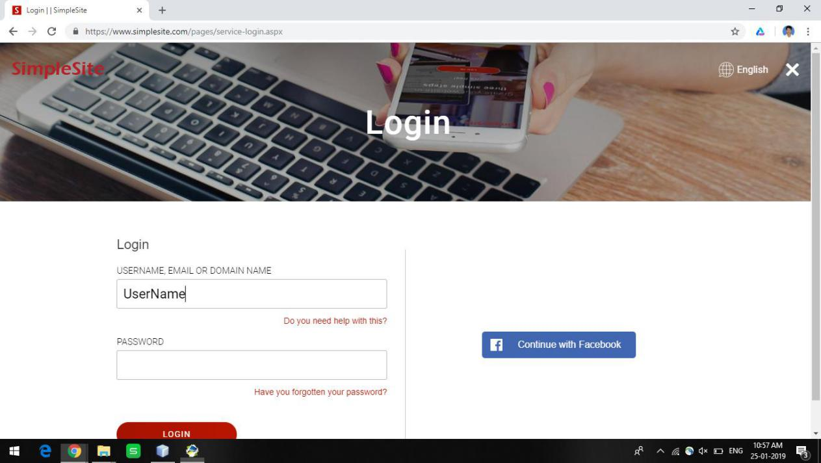

1. We have implement a “***Custom***” button to take a custom screenshot of a 'Step' which is not there in the Test Data sheet. This screenshot will be saved to a different file and requires the user to enter an ID and Description

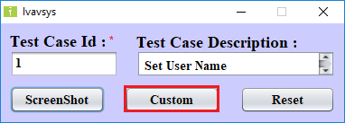

1. Enter Test Case ID and Description and click on the “***Screenshot***” button to take a Custom screenshot

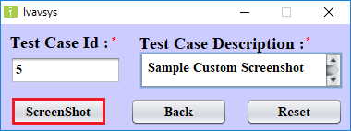

1. Each custom screenshot is saved to “Desktop\iScreenCaptureReports\CustomScreenshot” location in a new file with format TCID_<test case id>_<date>_<hh>_<mm>_<ss>.docx
2. Click on the “***Back***” button to go back to the Standard Screenshot window

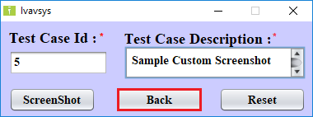

1. If you want to restart the screen capture process, then Click on the ‘***Reset***” button to start over. Once the utility is reset, all new screenshots will be saved to new file.

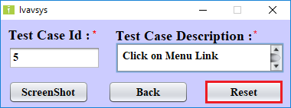

About Us

Ivavsys is an innovative and competitive services

provider in the areas of Specialized Software Testing.  
Founded in 2013 by senior IT experts with over two decades of industry experience, we have an exemplary track record of delivering specialized QA services to clients across the globe.

Having offices in Pune (India) and Chicago (USA) we are now a team of 50+ highly skilled QA associates catering to Performance, Automation and Manual Testing requirements.

We believe that an excellent customer experience is the key to success for any business, and strive towards achieving the same.

THANK YOU

*“The contents of this document are proprietary and confidential to Ivavsys Technologies Ltd. and may not be disclosed in whole or in part at any time, to any third party without the prior written consent of Ivavsys Technologies Ltd.”*

*“© 2019 Ivavsys Technologies Ltd. All rights reserved. Copyright in the whole and any part of this document belongs to Ivavsys Technologies Ltd. This work may not be used, sold, transferred, adapted, abridged, copied or reproduced in whole or in part, in any manner or form, or in any media, without the prior written consent of Ivavsys Technologies Ltd.”*